Comprehensive Assessment:

Online Shopping

Overview

To build web application which contains customer login, admin login, products, shopping cart. The Customers can register & login with their own credentials. And the customer credentials are validated. Admin can add different categories to the site and can add different products to each of the categories. Once customer entered with his own username and password, Customer can choose different items available in the site and add them to cart & they can checkout to order those products.

**System Specifications**

Hardware Requirements:

* PC With 8Gb Ram

Software Requirements:

* Azure Cloud Setup
* Visual Studio
* Dot Net
* Java Script
* HTML
* CSS
* MS SQL
* Azure Databases

Steps

As to build website we required front end, backend and database

1. For Front End (Html, CSS, Bootstrap, React)
2. For Back End (Dot Net)
3. For Database (MS SQL, Azure Cloud)

The core Modules are

* Admin
* Products
* Customer

Products:

This module contains product name, and related image, and cost of it and also product description for the products like mobiles, laptops, bags, etc. whatever customer wants from the shopping store.

Admin:

Admin get all access like Admin can add new Categories in products in the same way admin can also delete that category and also products in that particular categories.

Customer:

Customer can add those products to cart and can place order of those products.

For that we need customer details like name, mobile number, email Id, password etc…

Implementation

First we need to install MS SQL and Visual Studio

I used Database First approach, So we need to create Database first in order to do this we need to open MS SQL

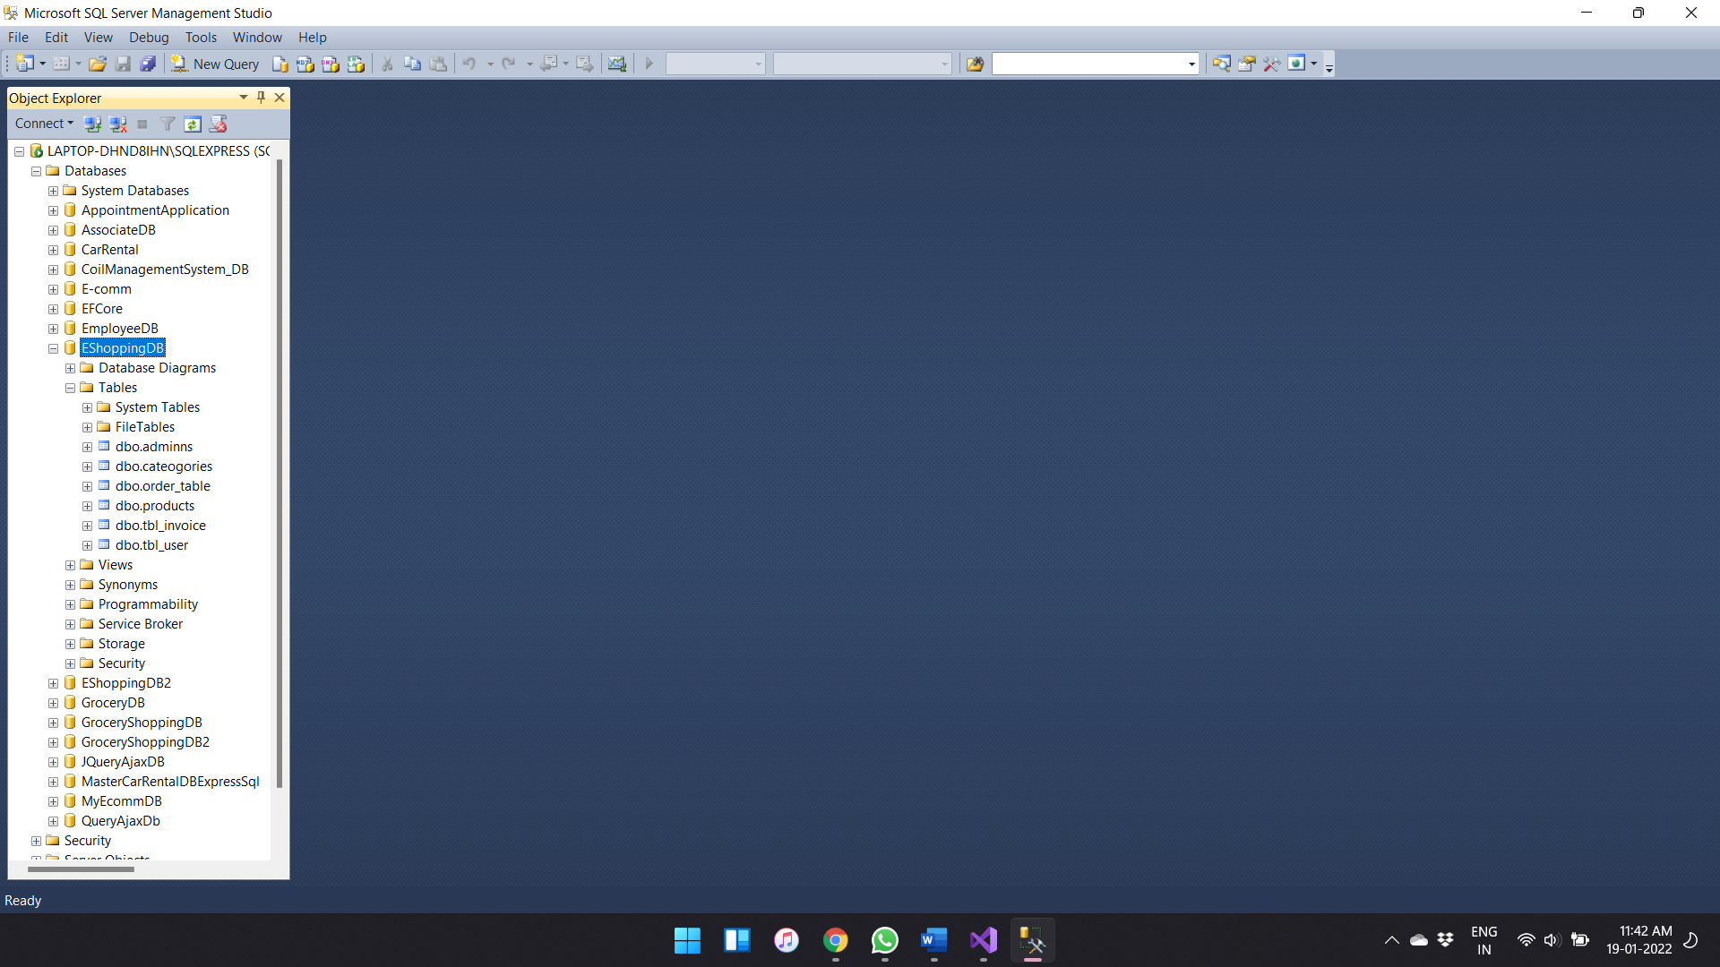

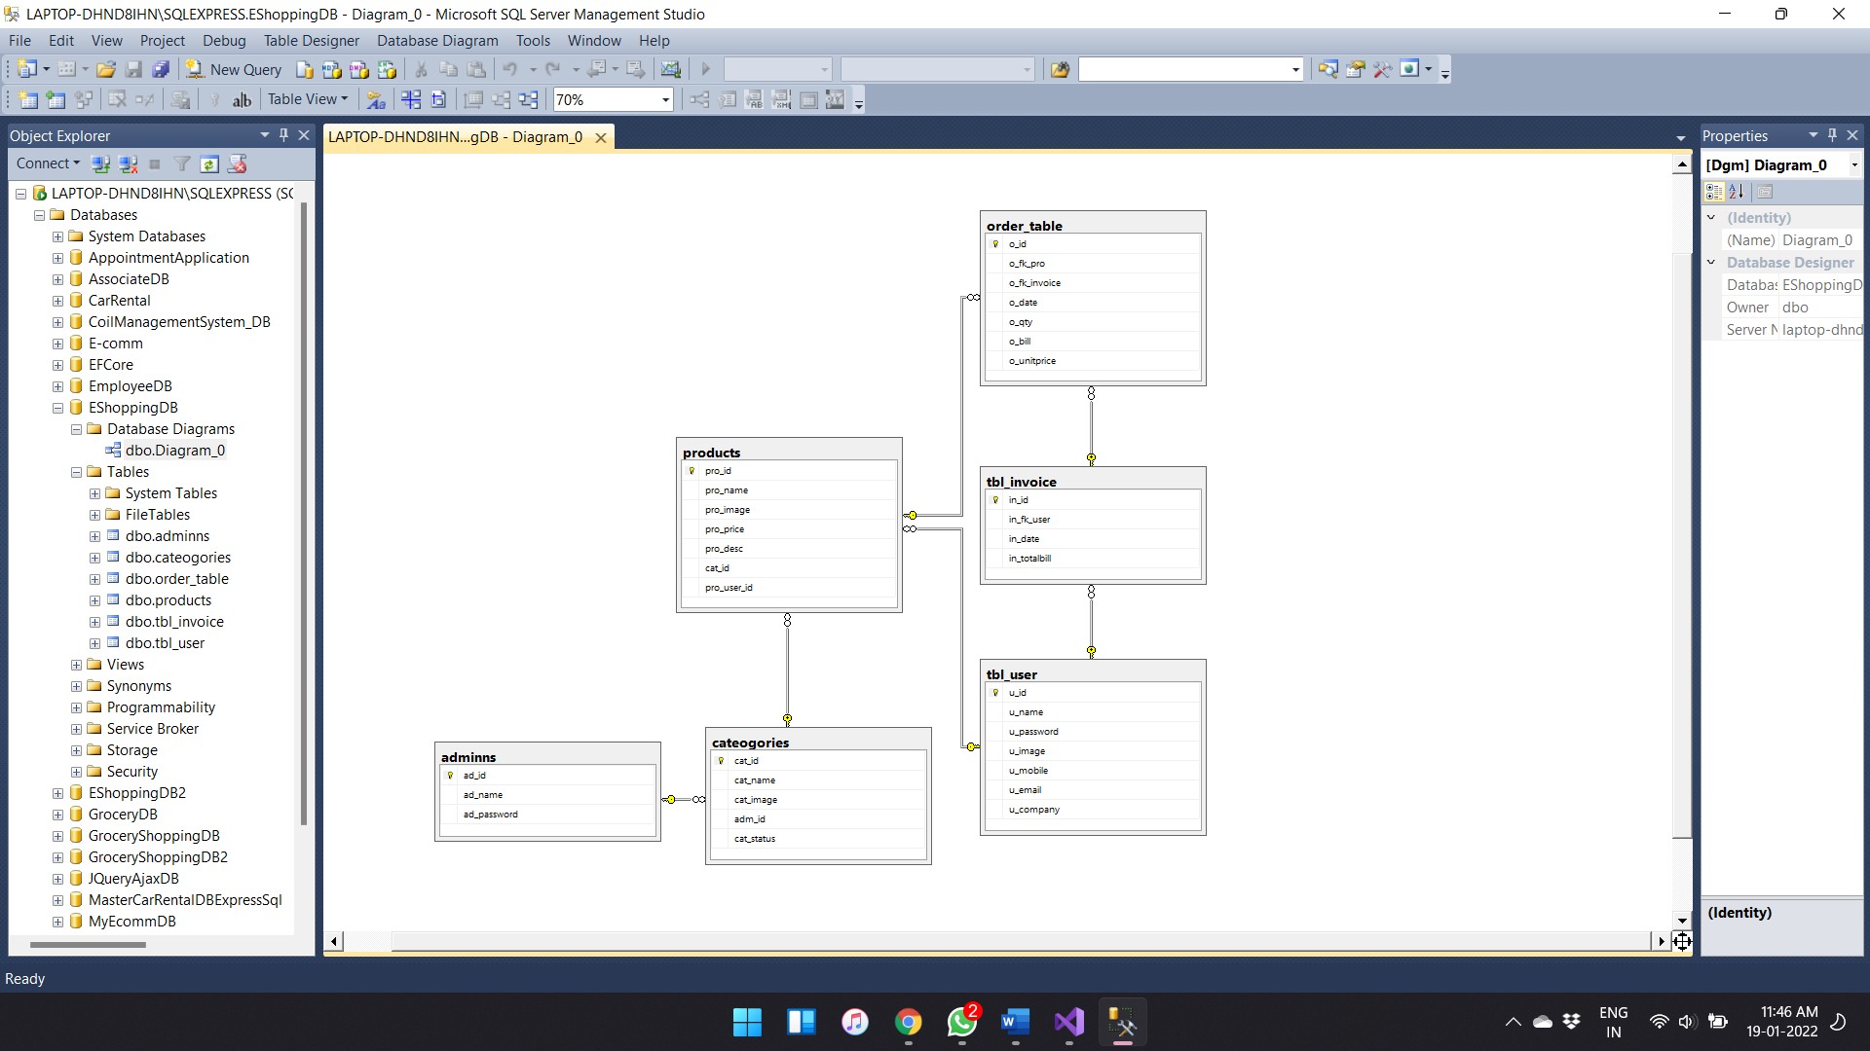

In order to create project we need to click on the create new project

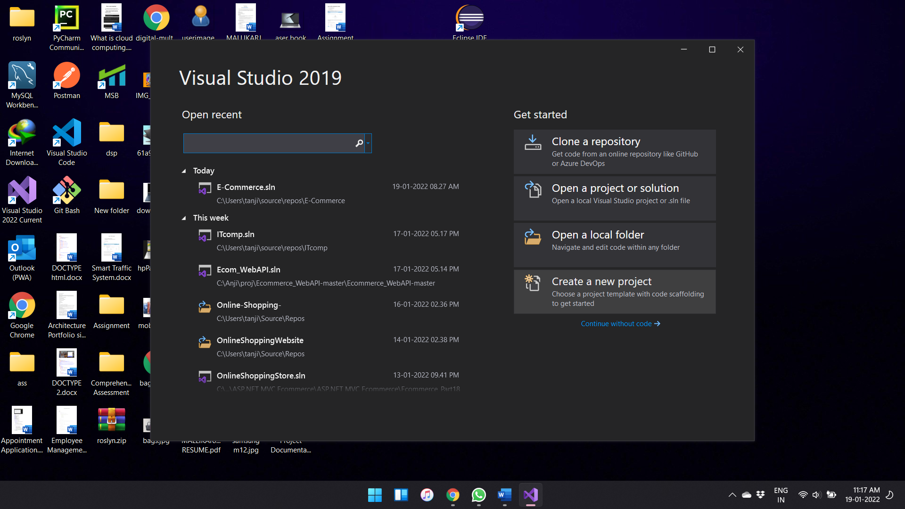

After this step we need to select the required template for the project

As we need to build the web application I choose asp.net web application

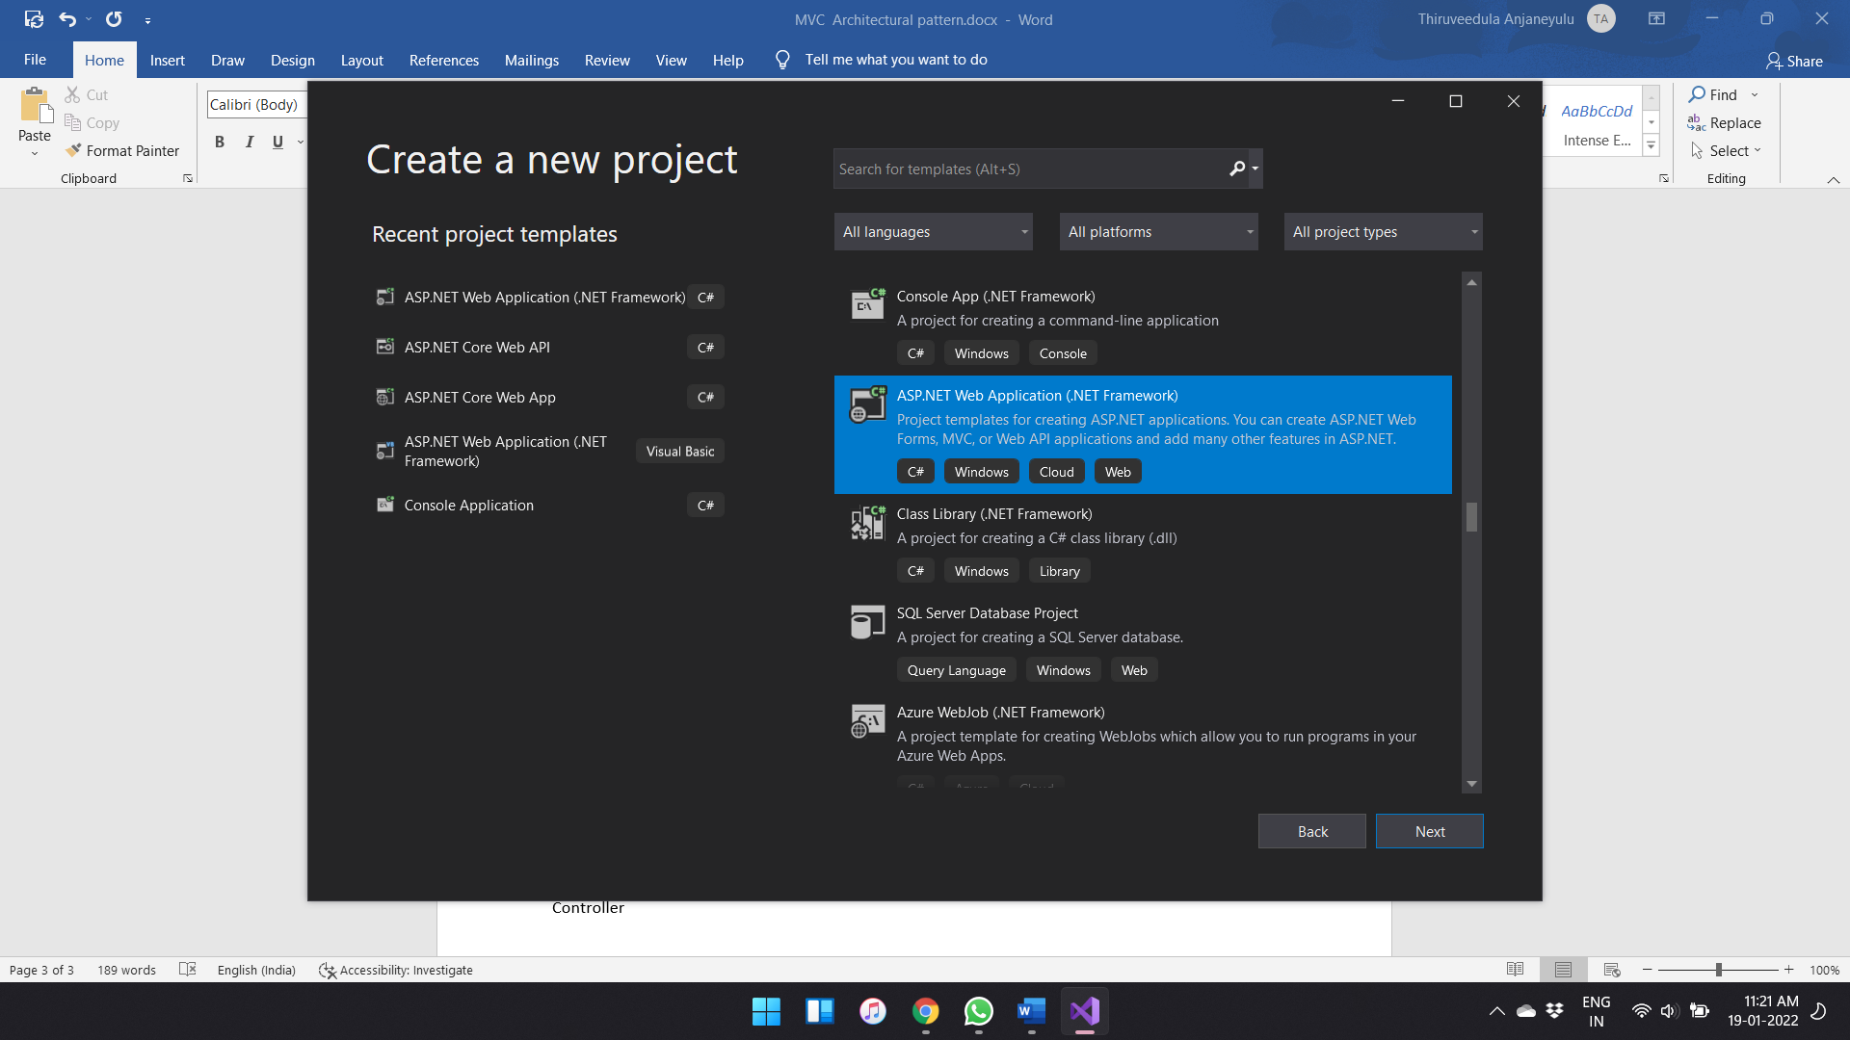

Then going to next step it asks basic requirements like name of the project and the location, framework version

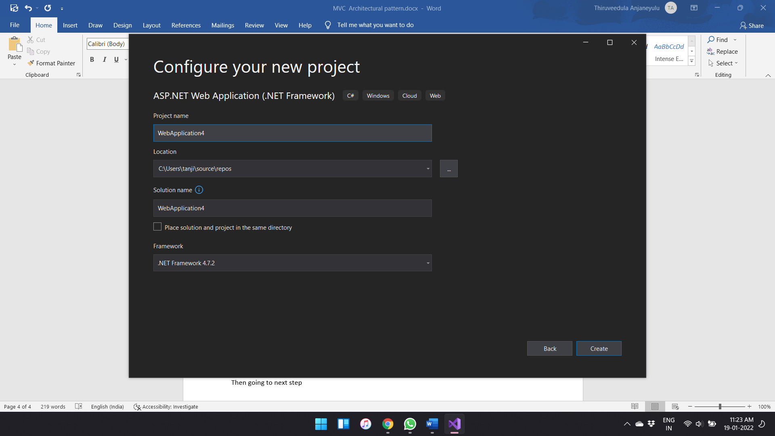

Then in the next step after clicking on the create button

It asks which template is required in order to build web application

I choose MVC template

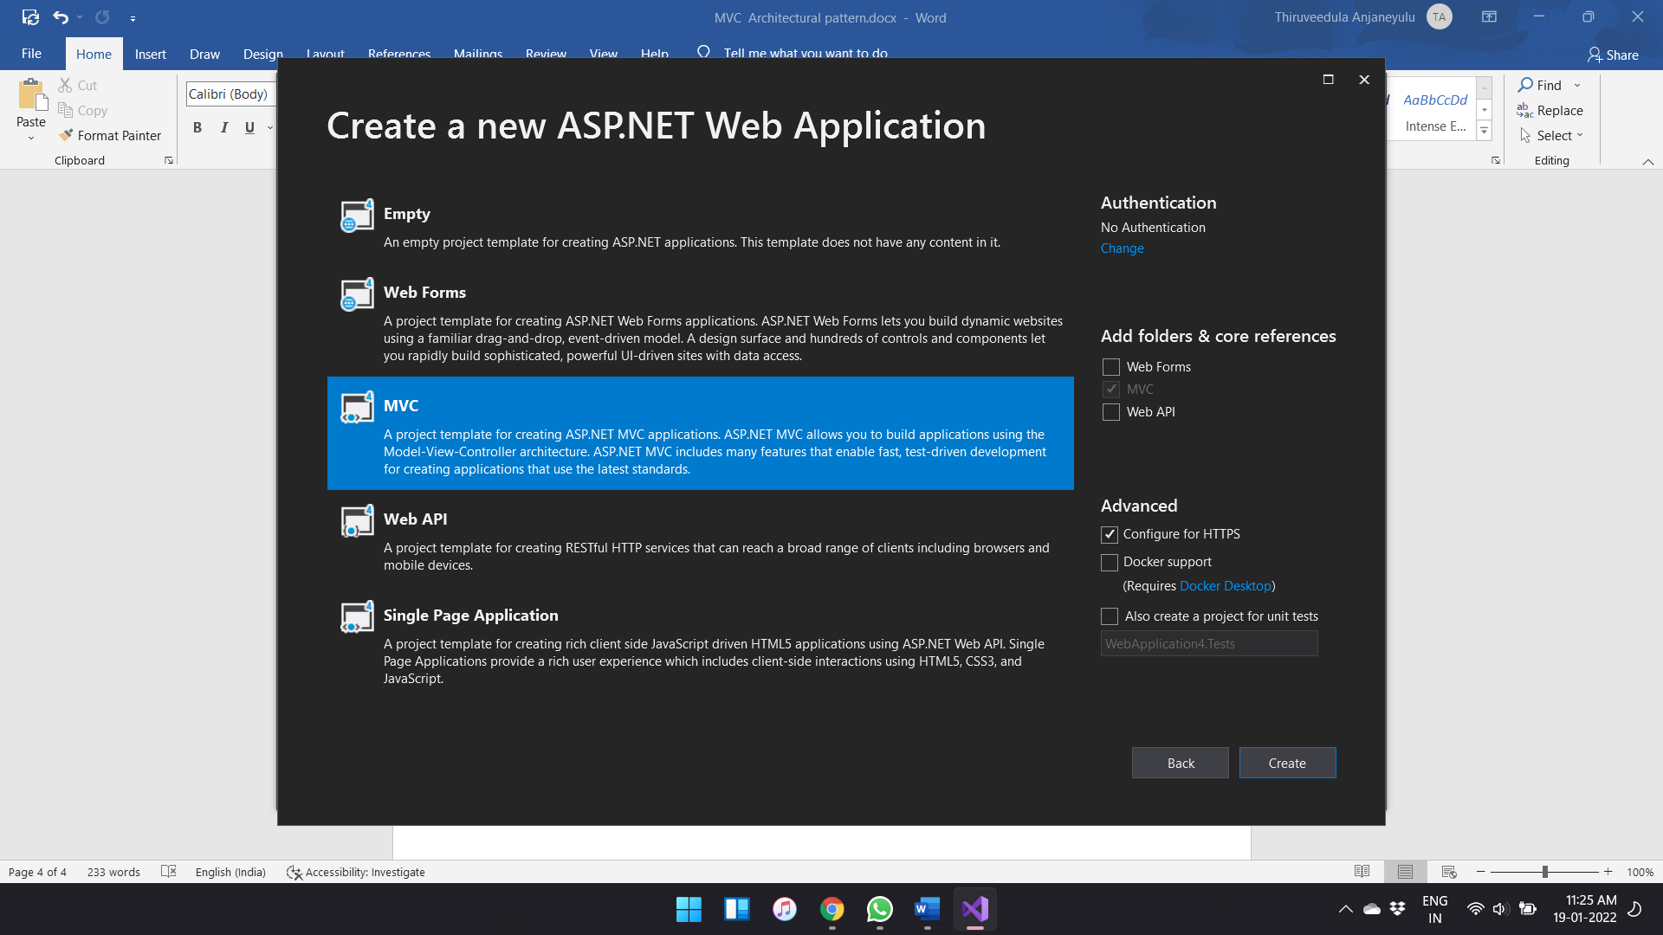

After creating the project it looks like

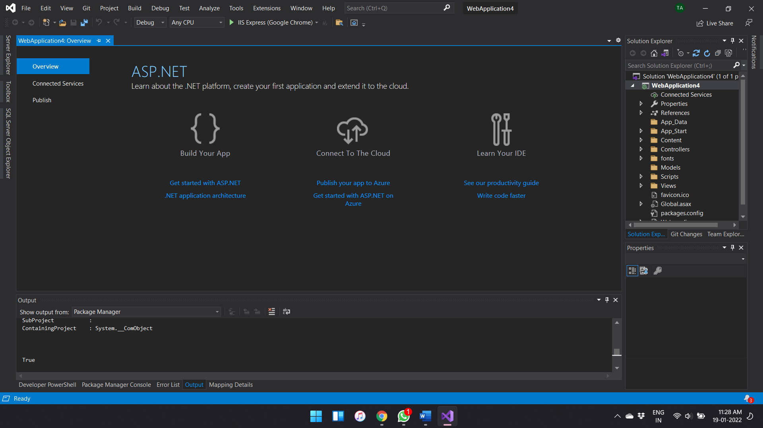

MVC Architecture pattern

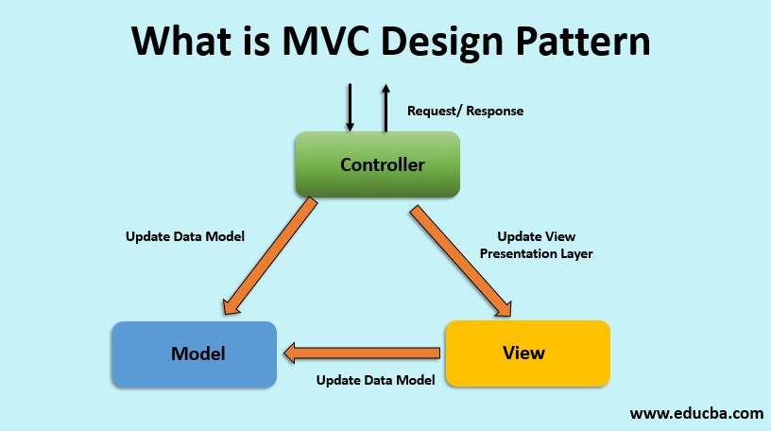

The MVC model defines web applications with 3 logic layers:

* The business layer (Model logic) Ex. Customer, Products, etc..
* The display layer (View logic) The html markup that we display to user
* The input control (Controller logic) Responsible for handling an HTTP Request.

The main task is to connect the MS SQL database to this Visual Studio

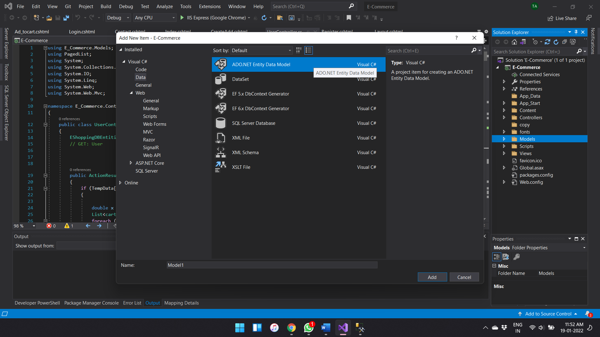

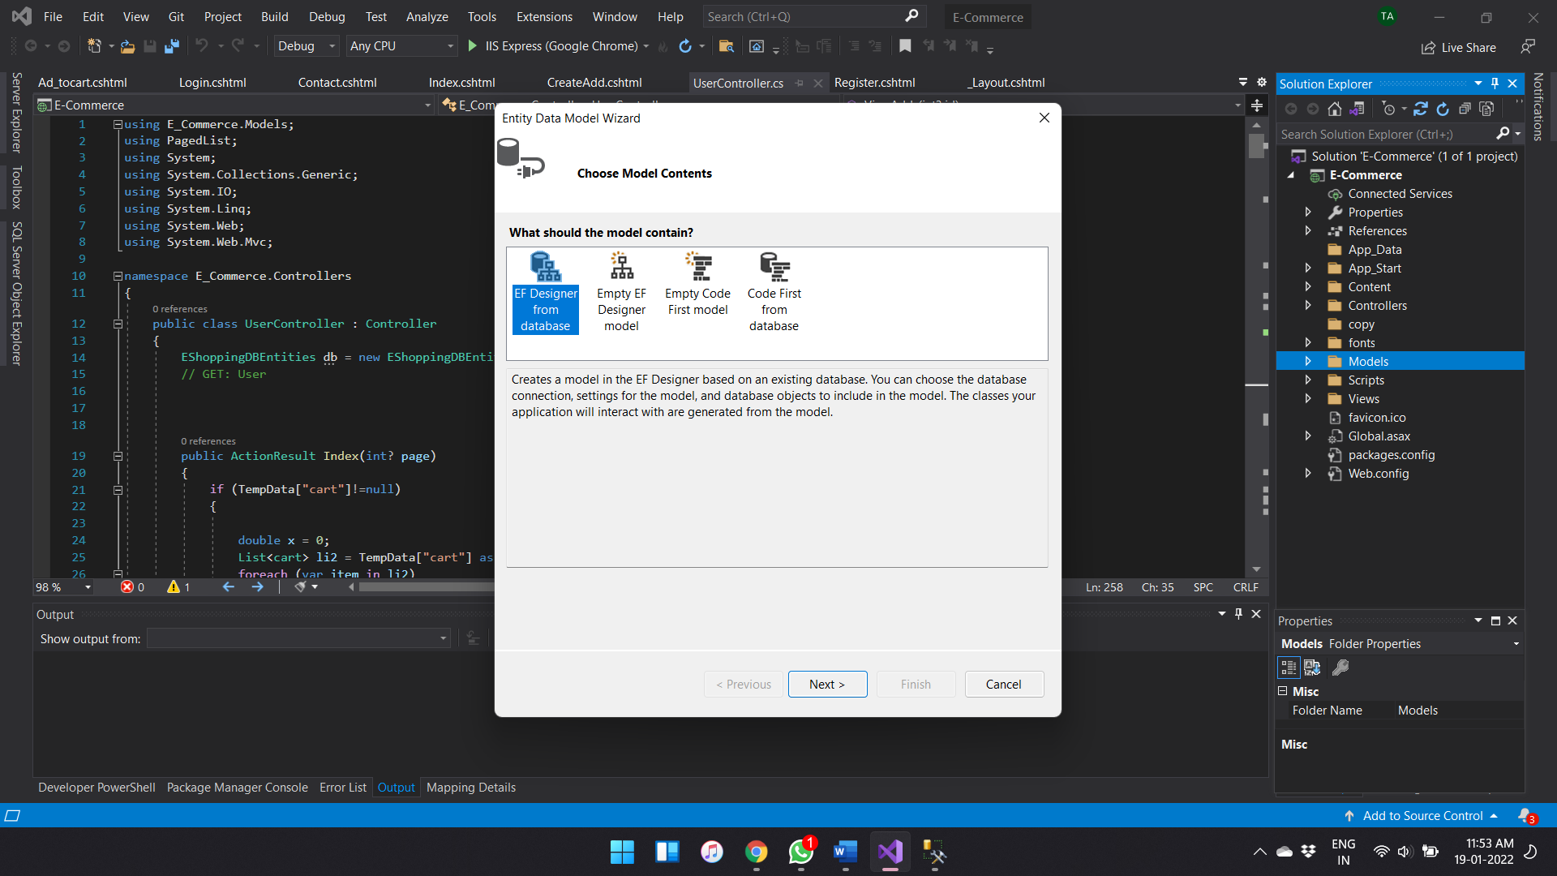

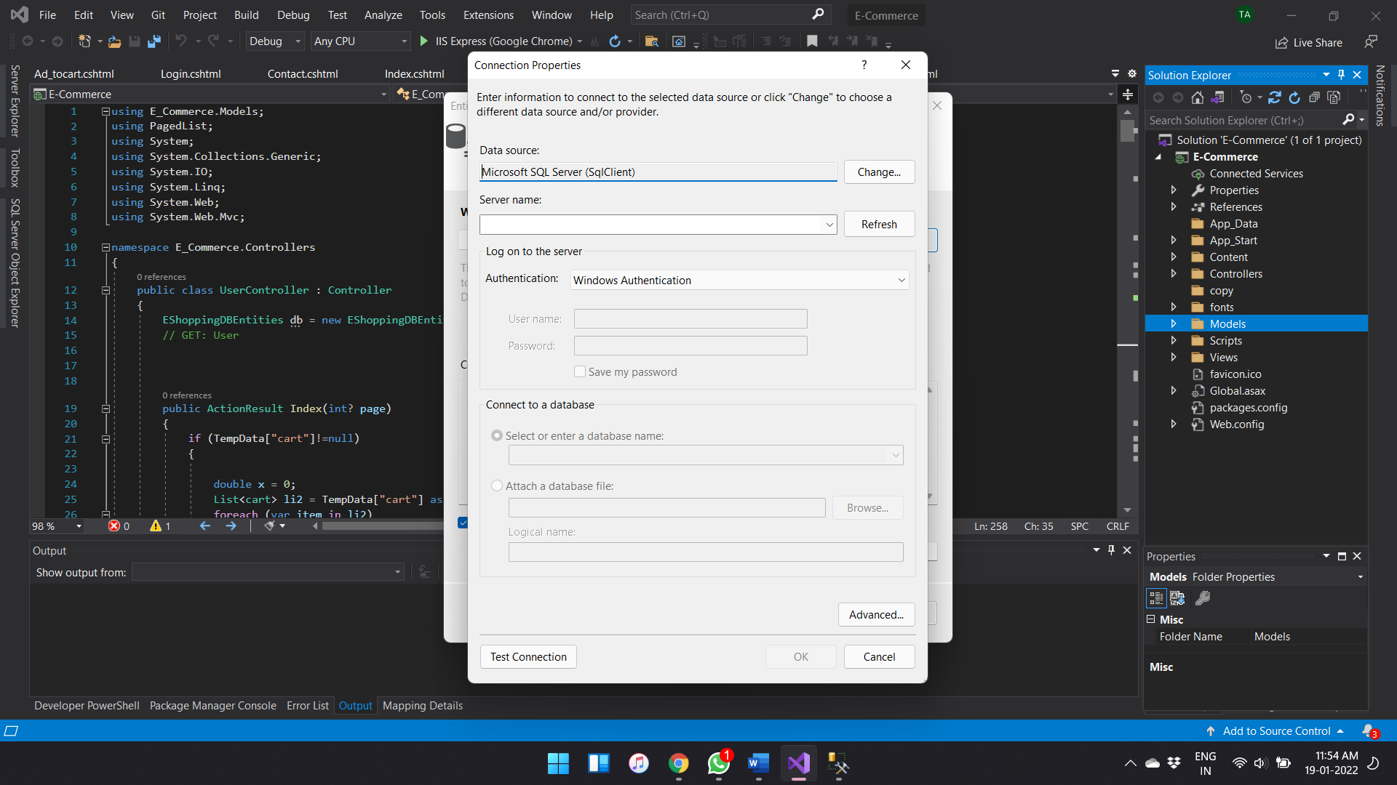

Check weather the model is added or not

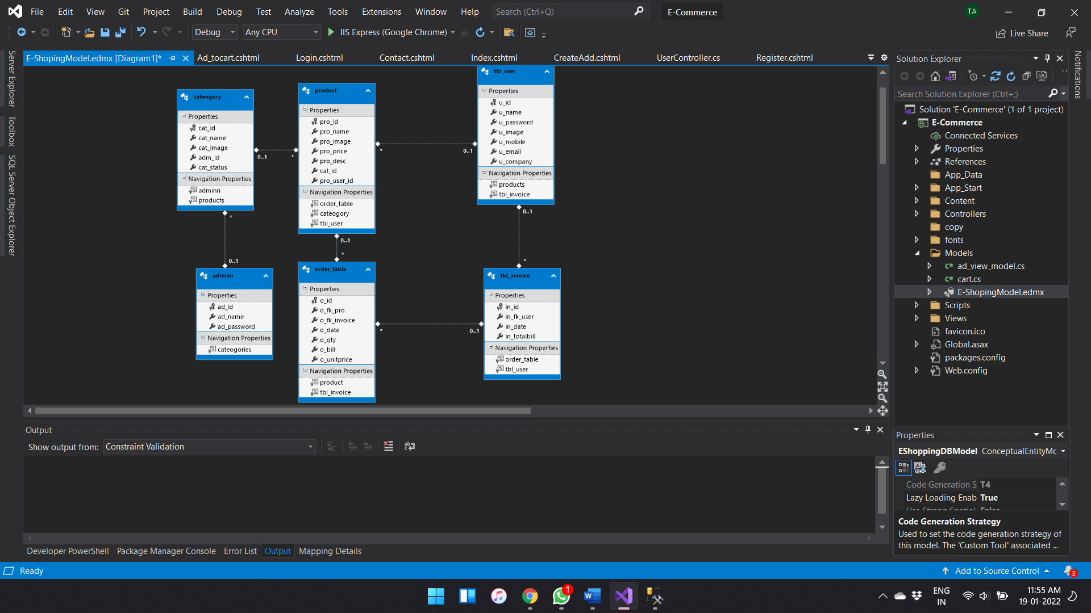

Then creating of controller

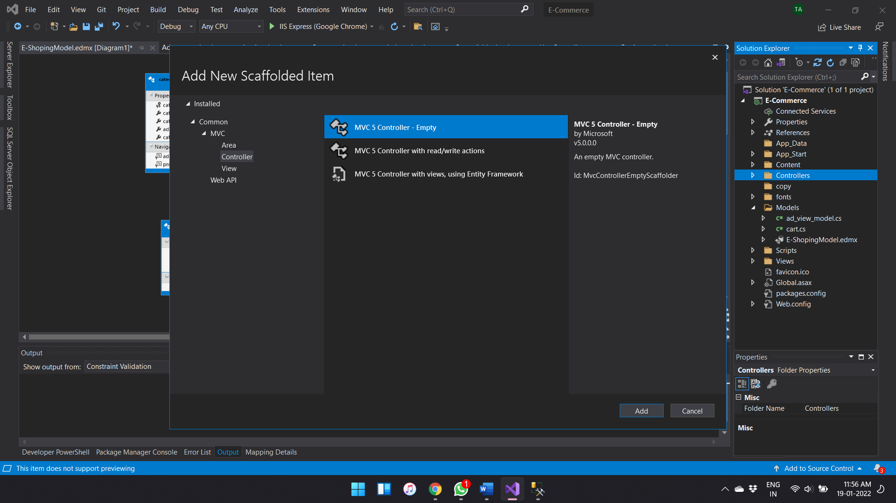

Adding Views

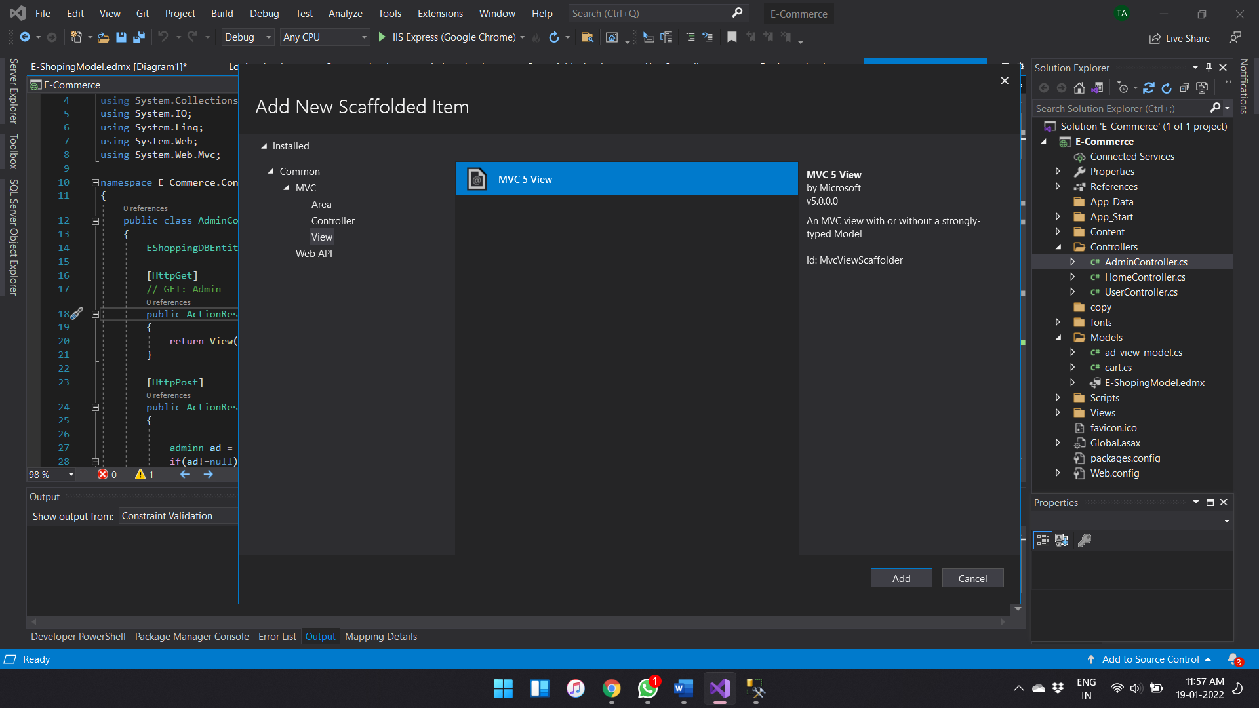

After adding all controllers and views

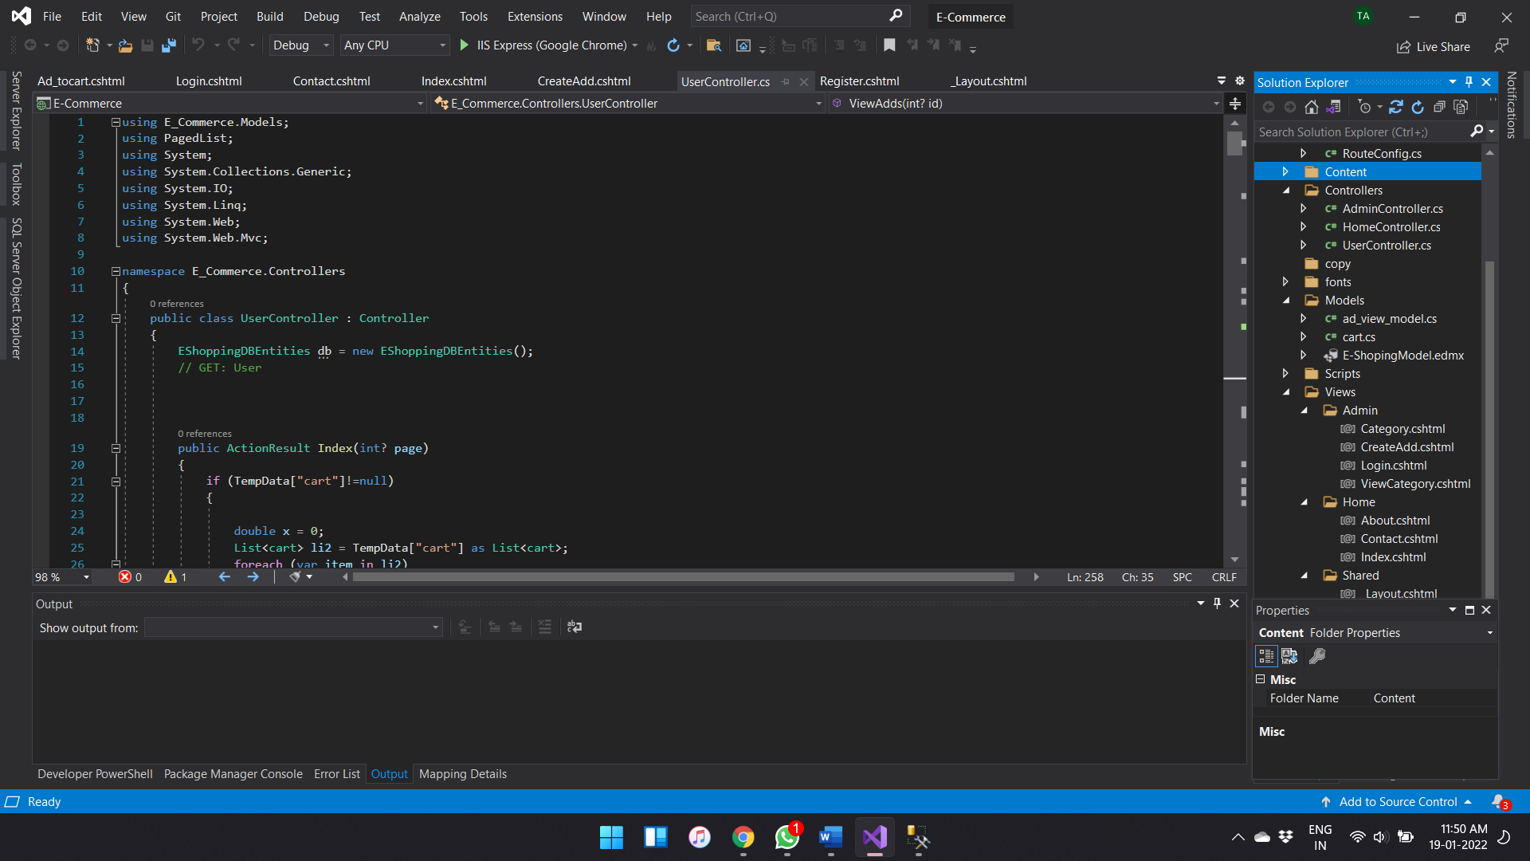

The output screen of the projects

Home Page:

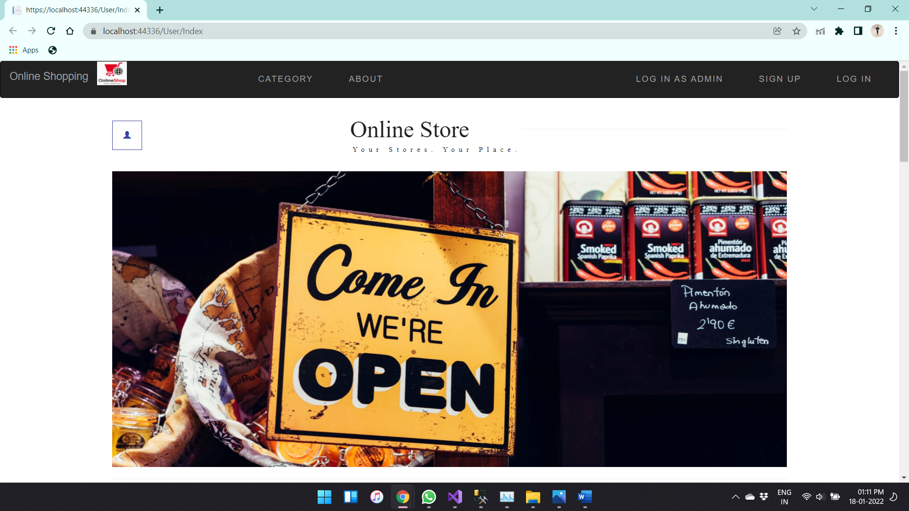

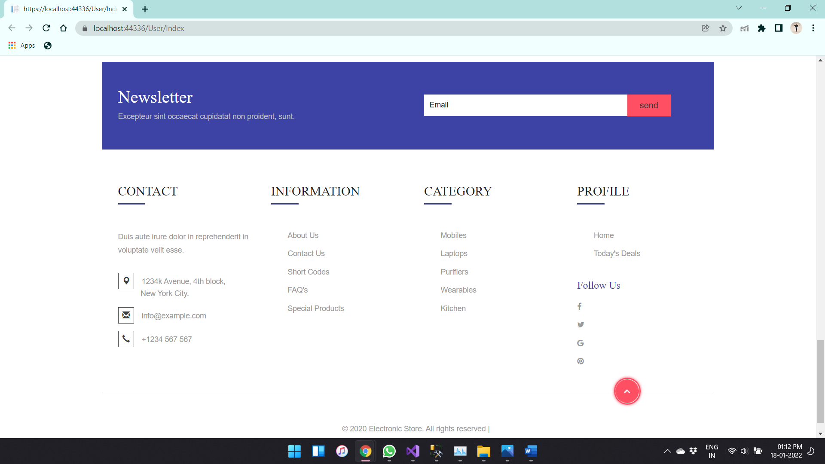

Admin Login

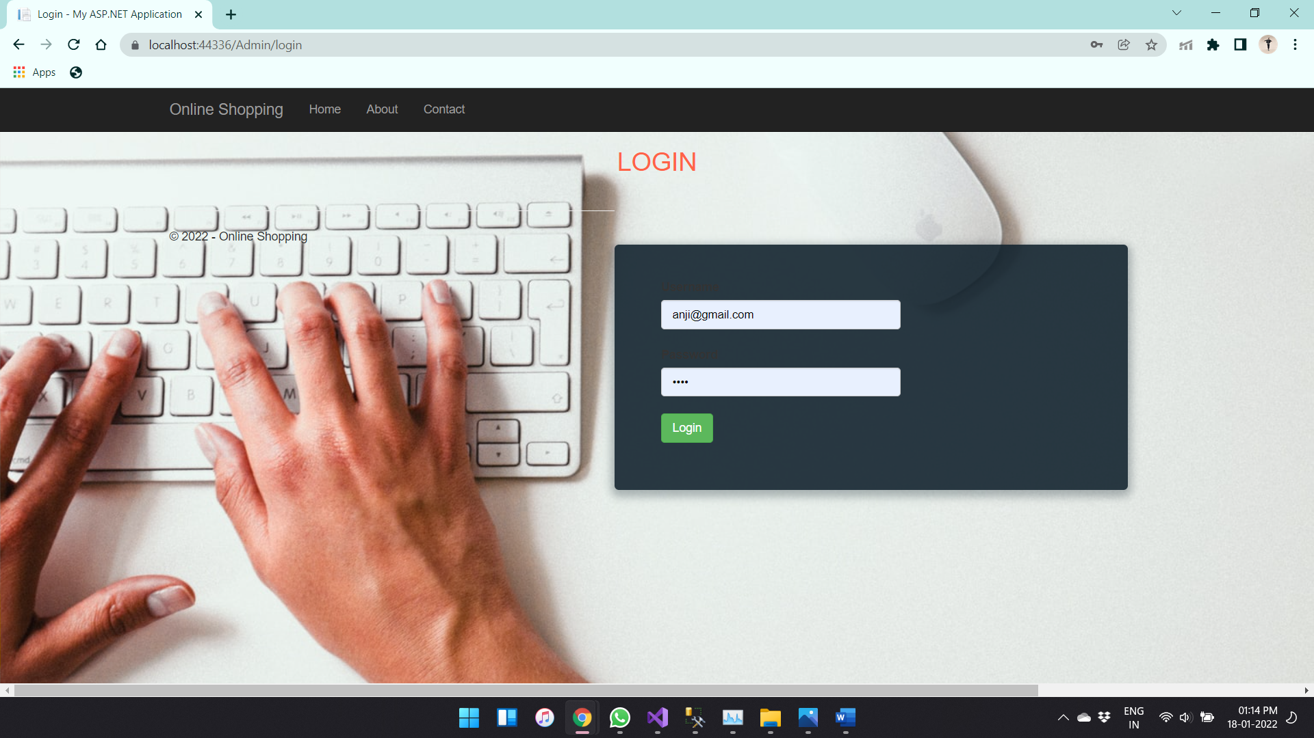

Add category:

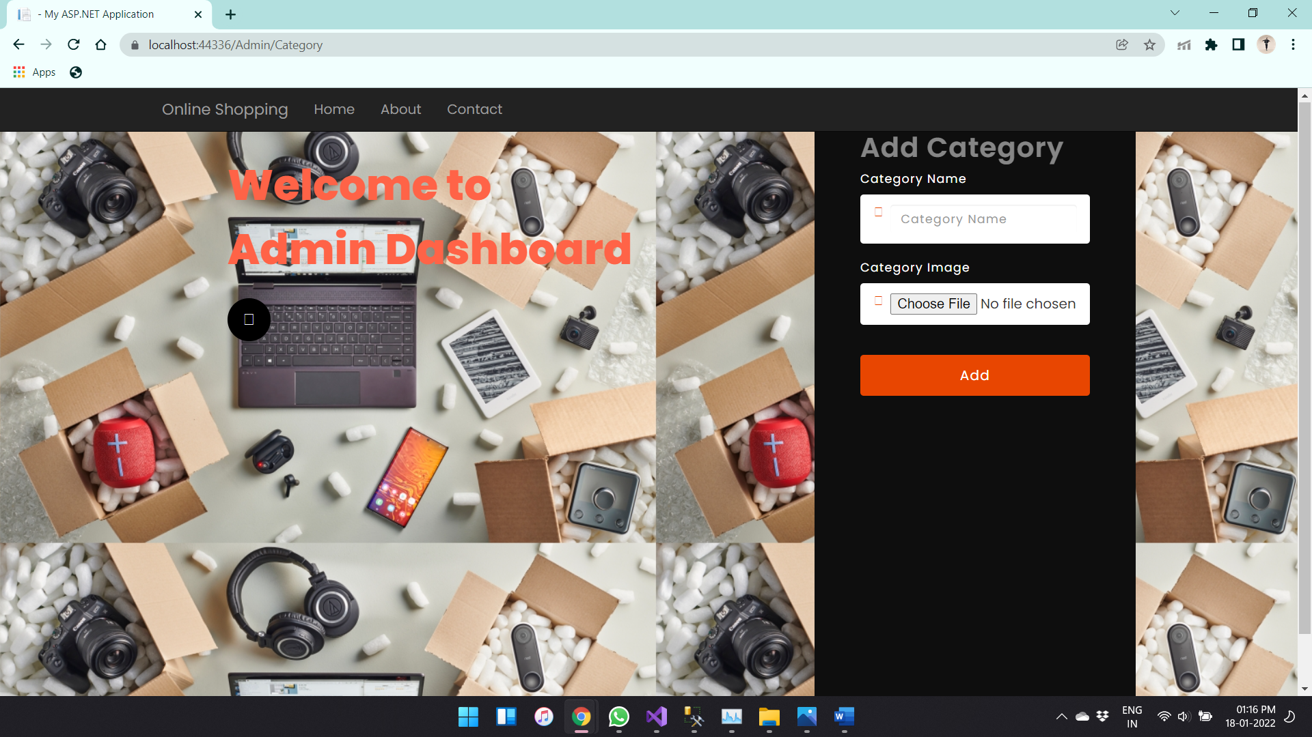

View category

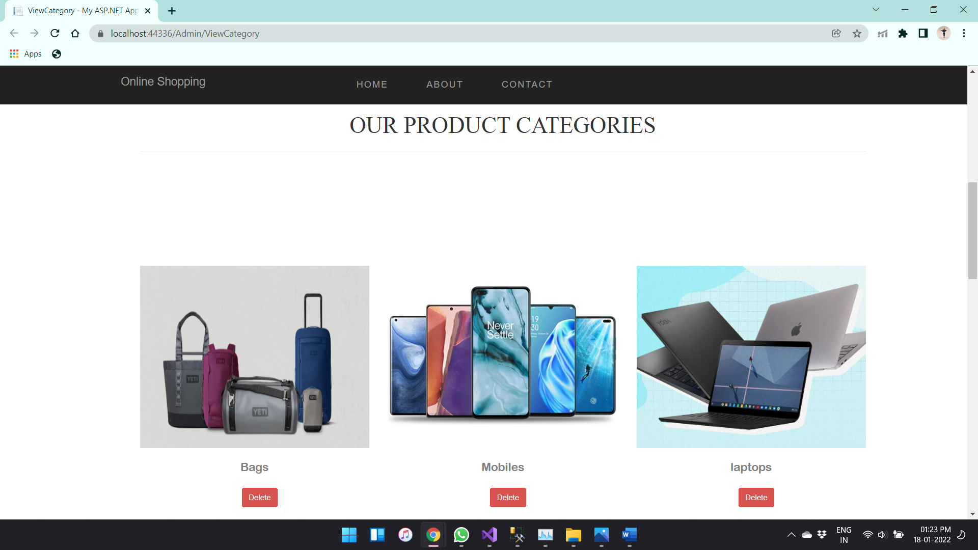

Sign Up page:

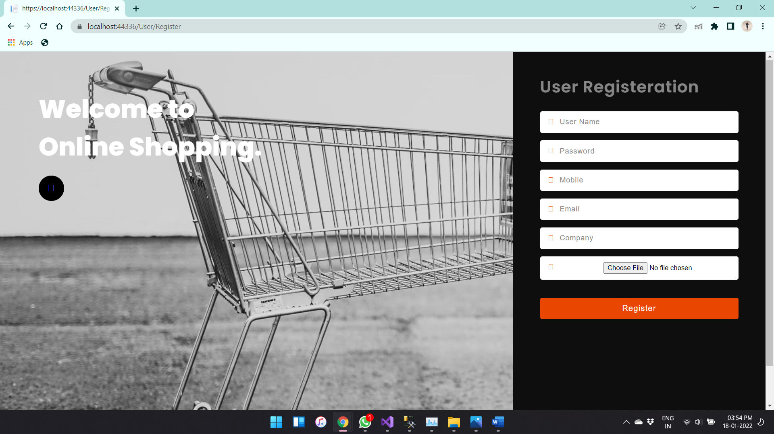

Data after User Sign Up

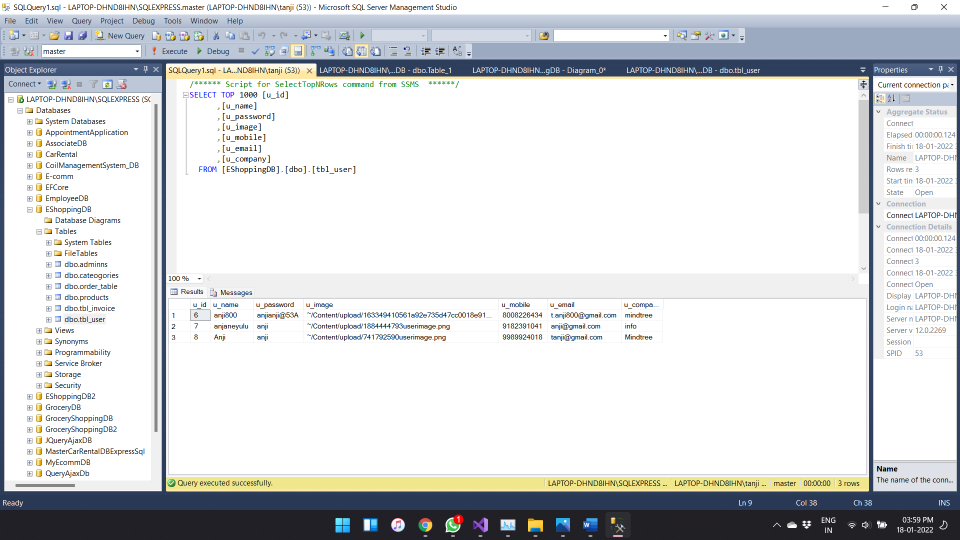

User Log In

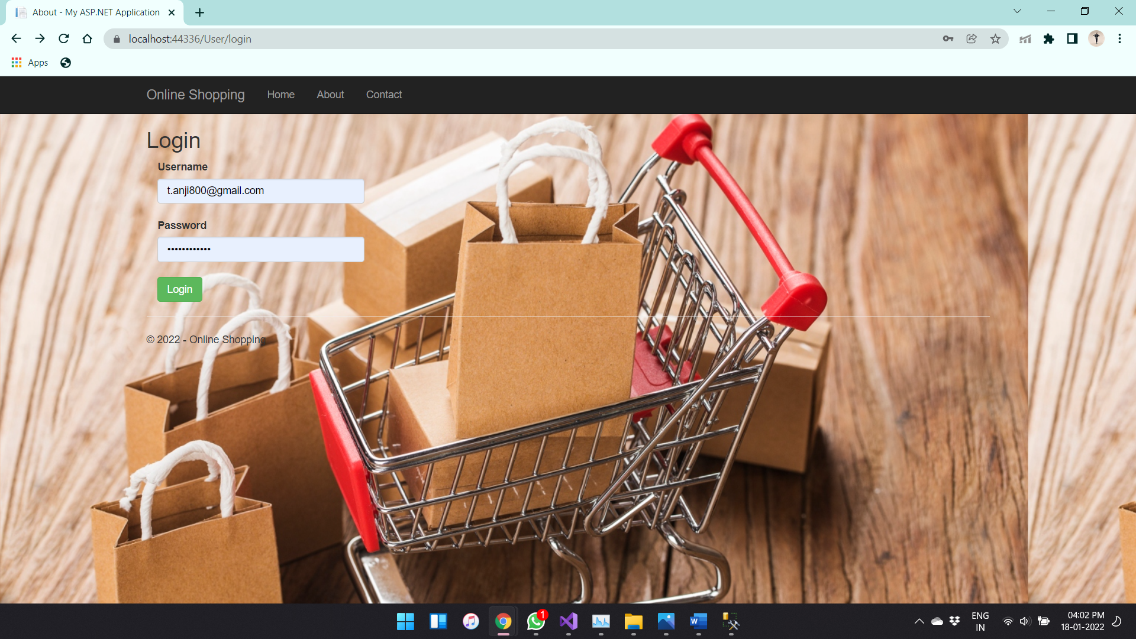

Products

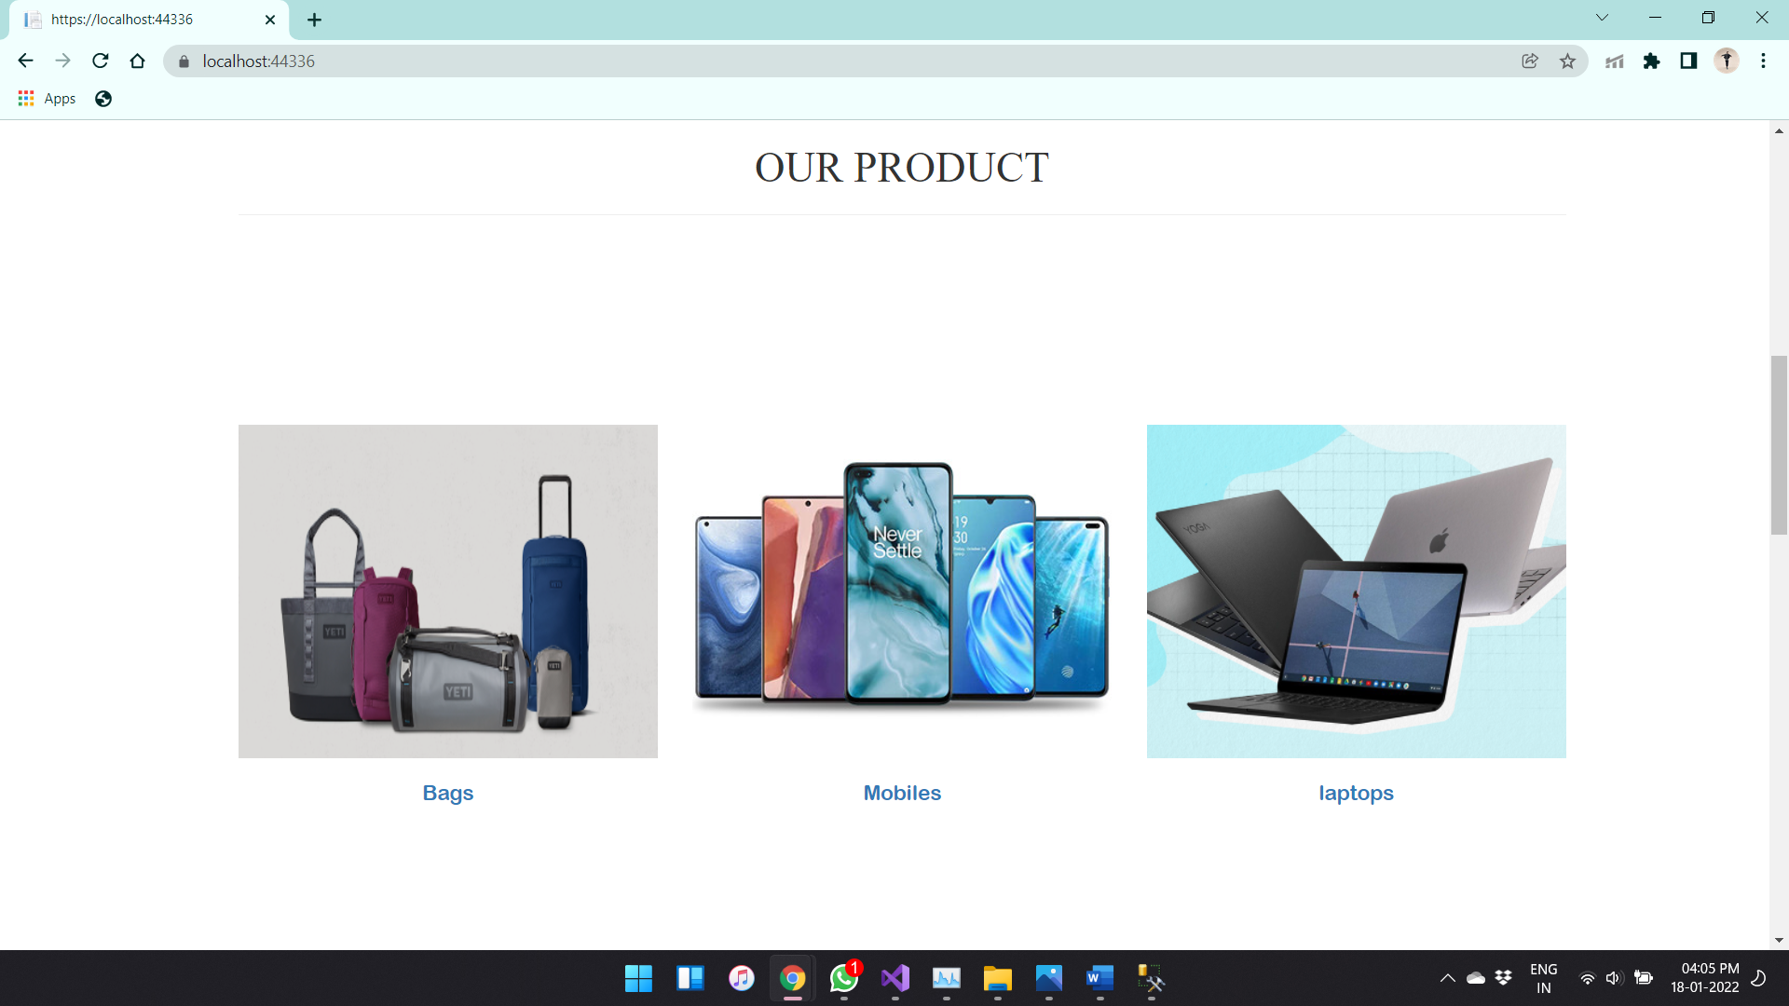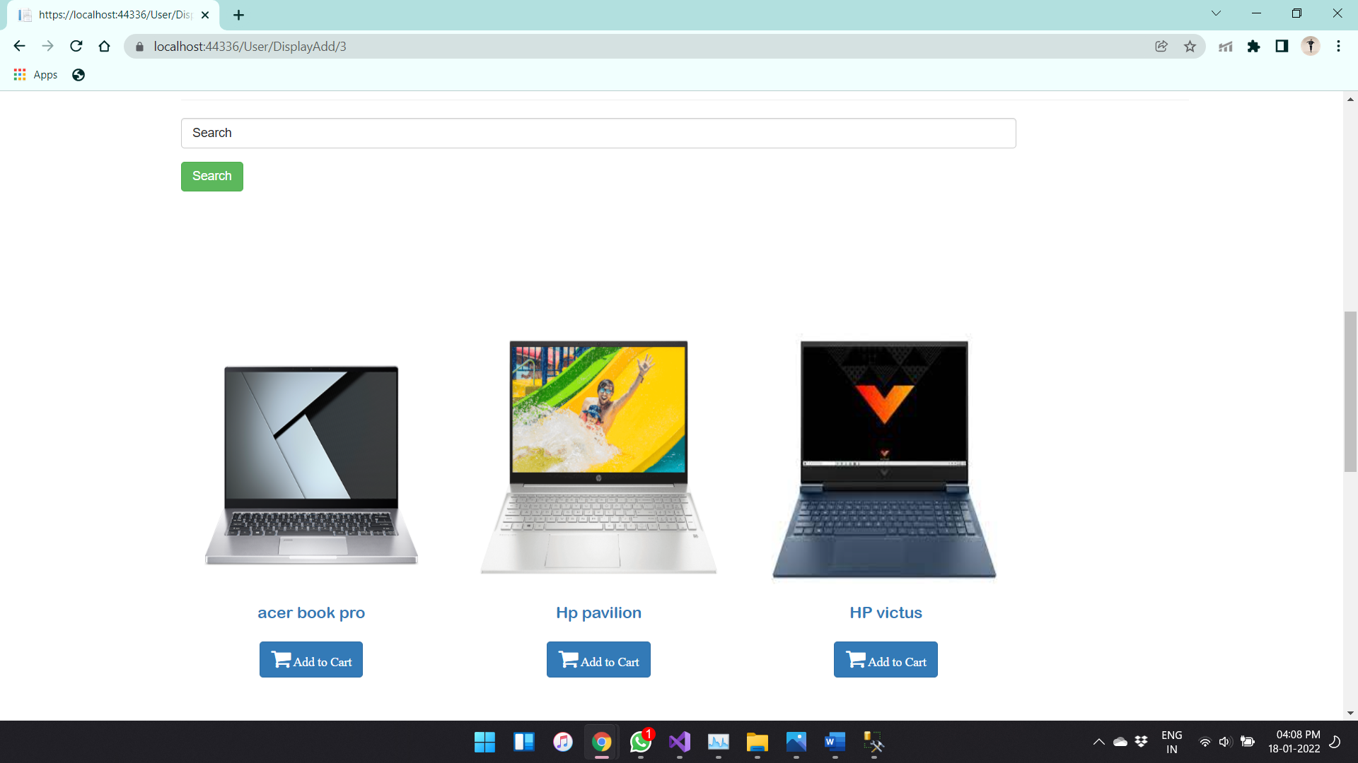

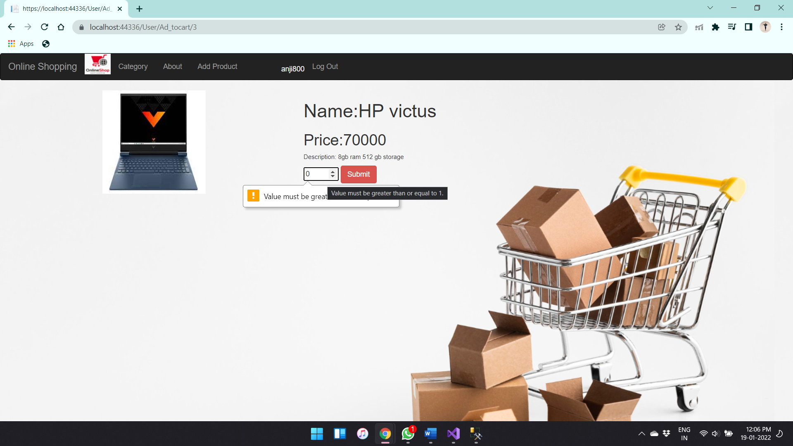

Add Products:

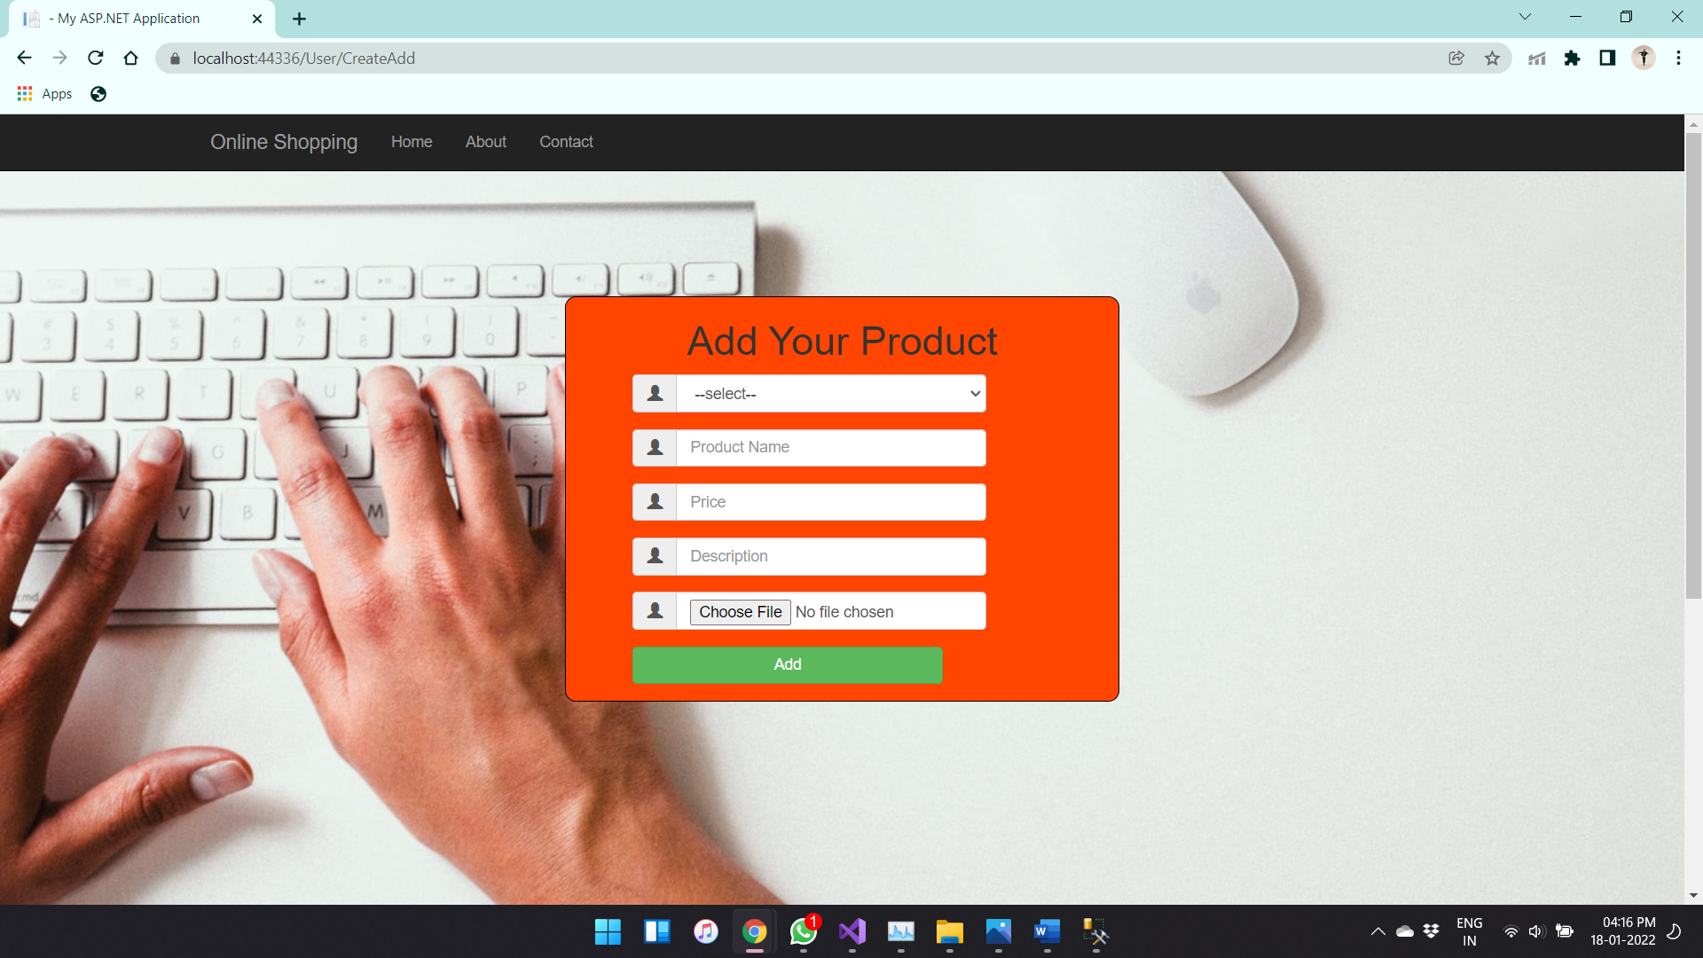

Check Out:

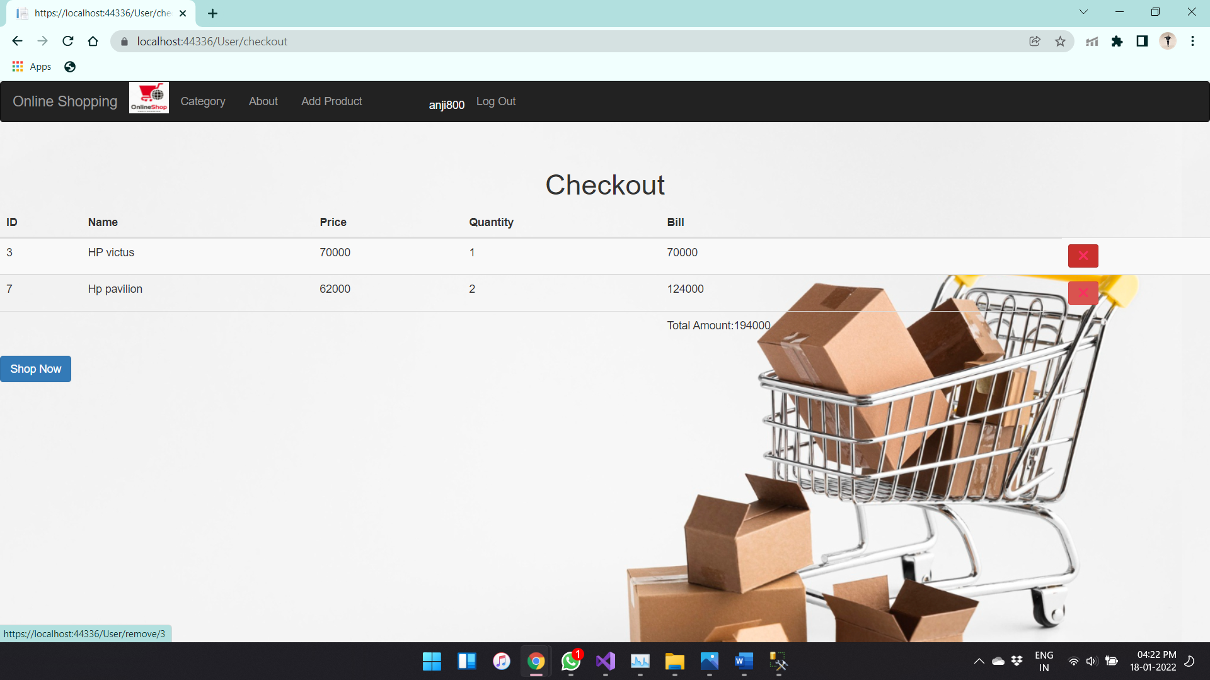

Data in Database:

Products data:

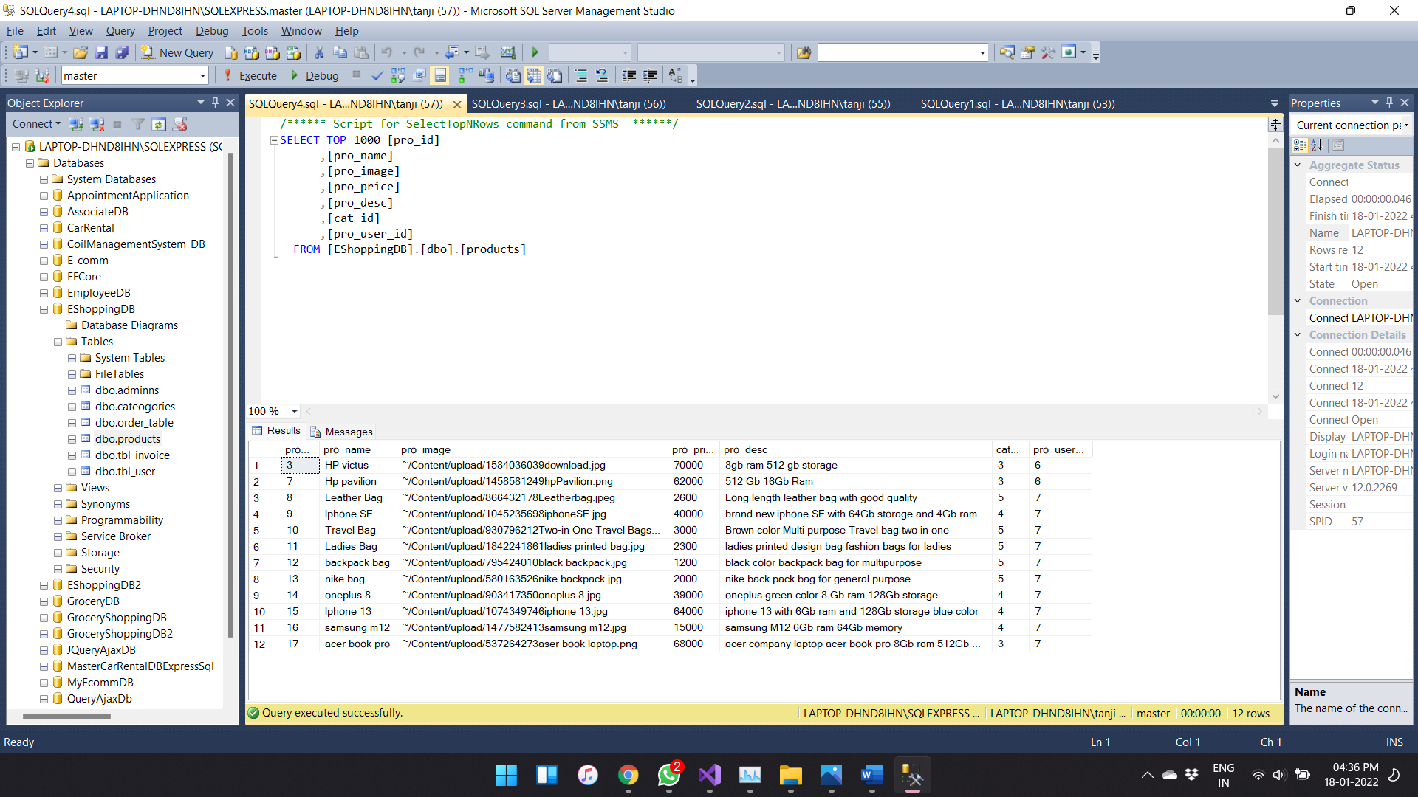

Order Data:

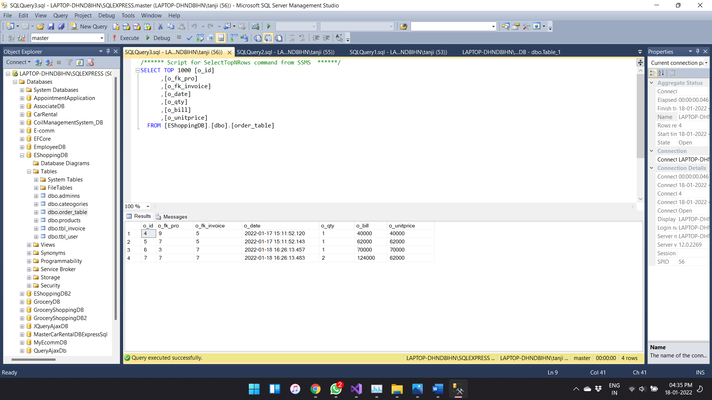

Invoice Data:

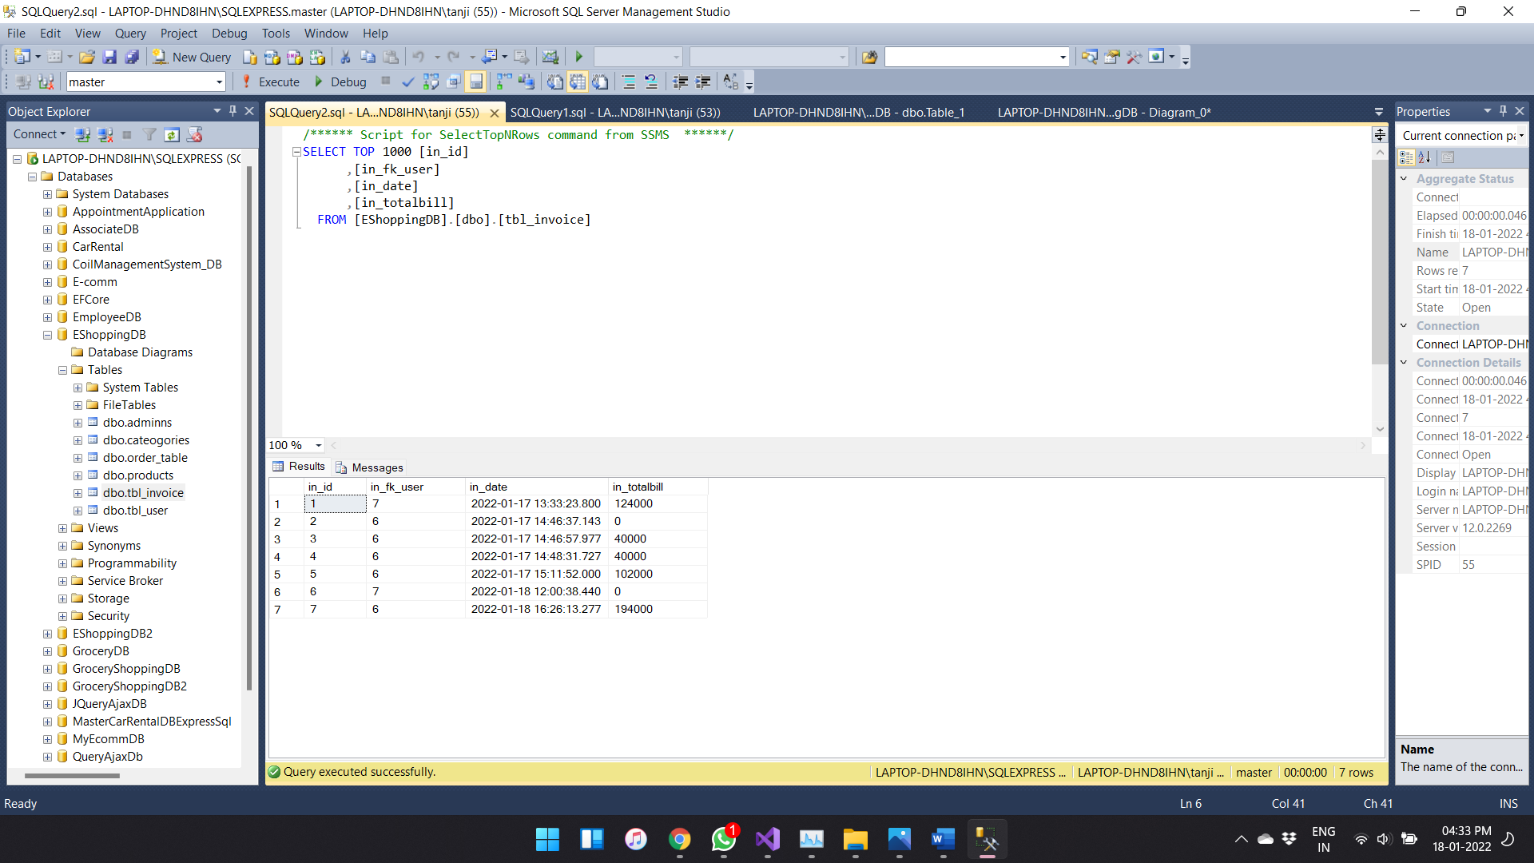

Azure Part:

Creating Virtual Machine:

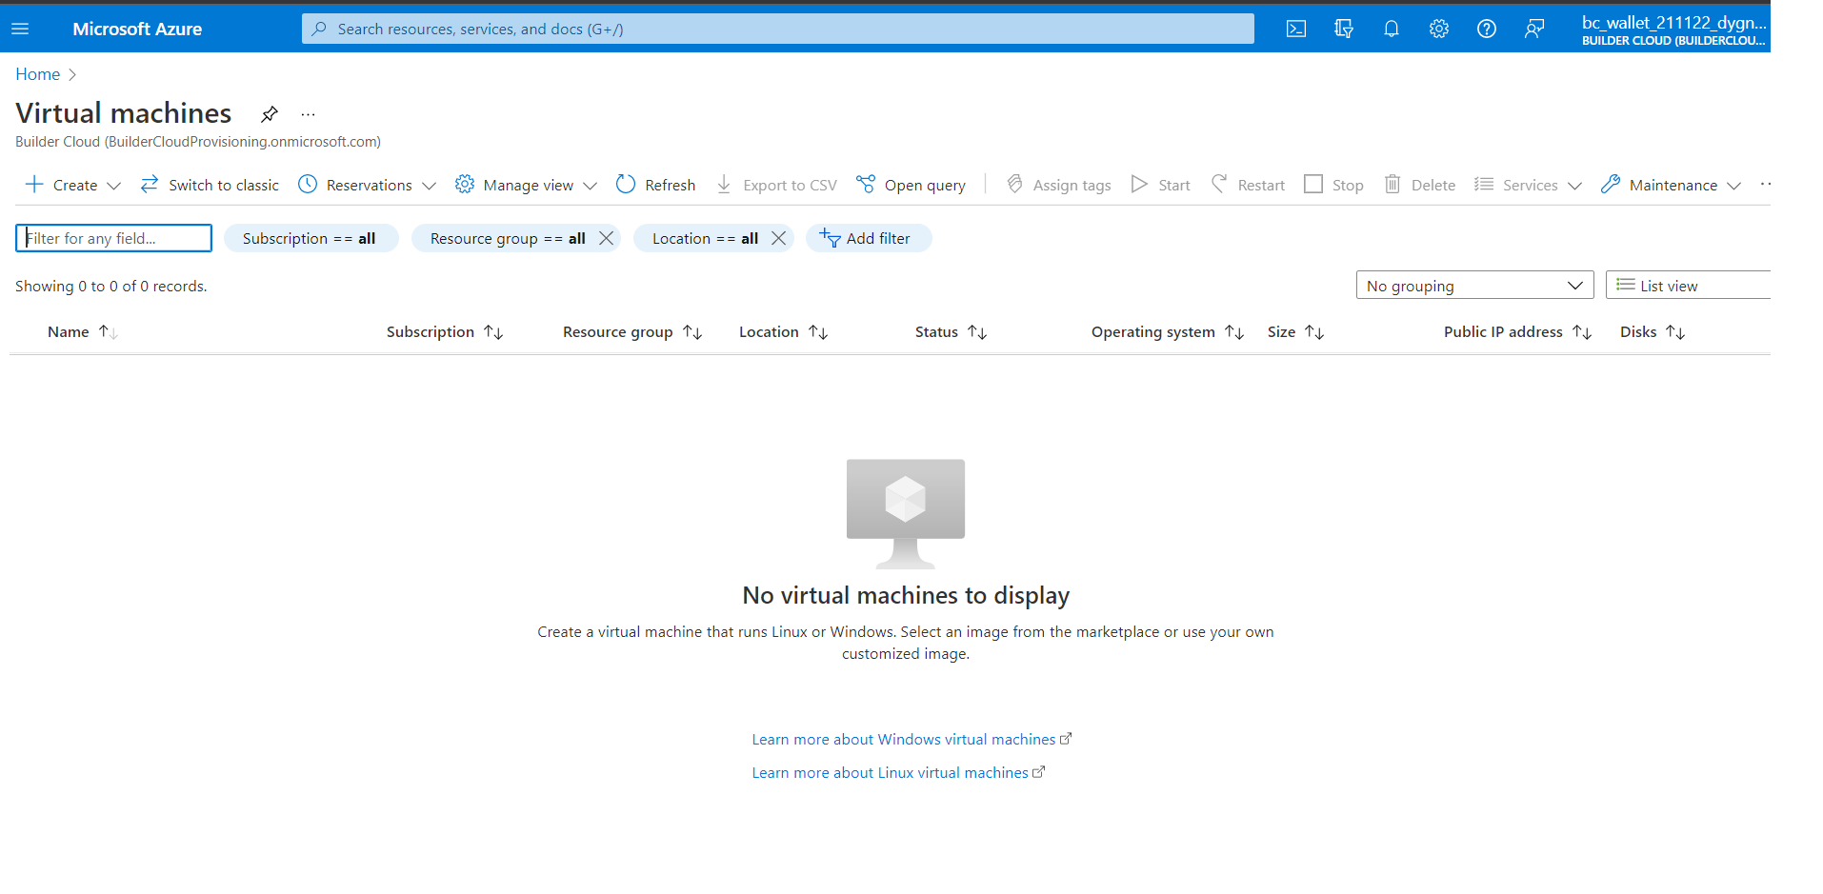

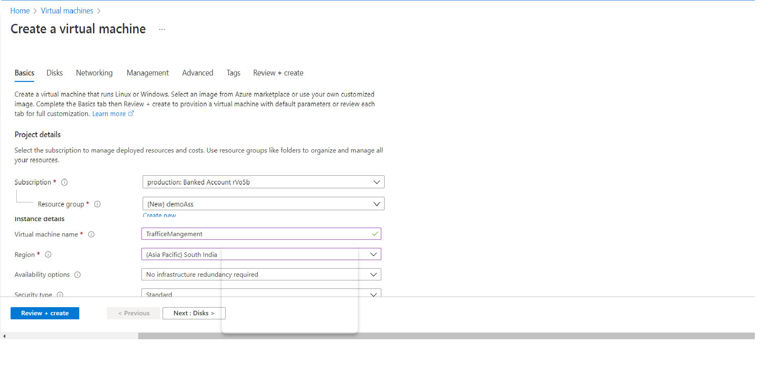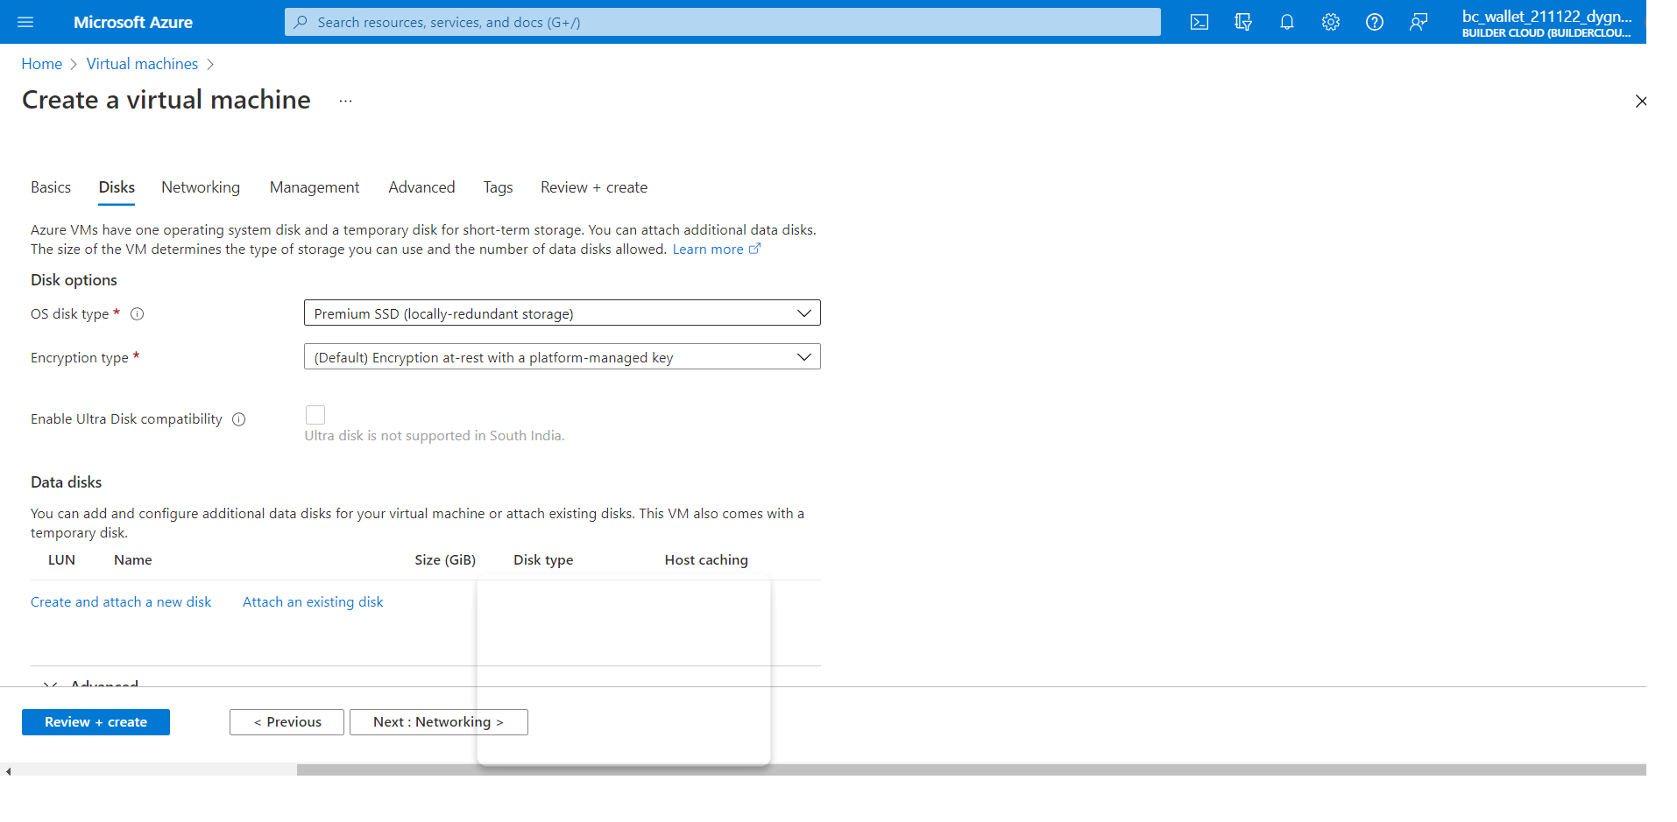

Creating Web App:

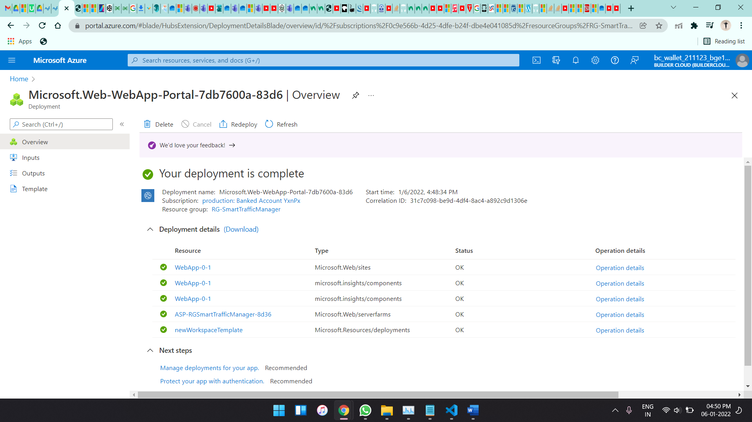

Traffic Manager:

